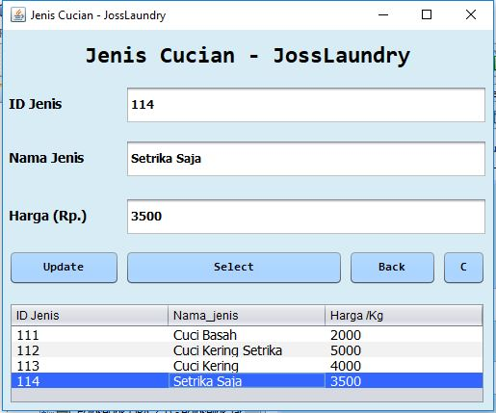

**Script Code Update jenis_cucian :**

private void jButton2ActionPerformed(java.awt.event.ActionEvent evt) {

try {

String sql = "UPDATE jenis_cucian SET nama_jenis = '"

+ txnama.getText() + "', harga = "

+ txharga.getText() + " WHERE id_jenis = "

+ txid.getText();

PreparedStatement pst = conn.prepareStatement(sql);

pst.execute();

clear();

tableload(jTable1);

JOptionPane.showMessageDialog(null, "Data Updated");

} catch (Exception ex) {

JOptionPane.showMessageDialog(null, ex.getMessage());

}

}